Student: Brian Johnston

Class COP2362

Assignment 3-4

Screenshot

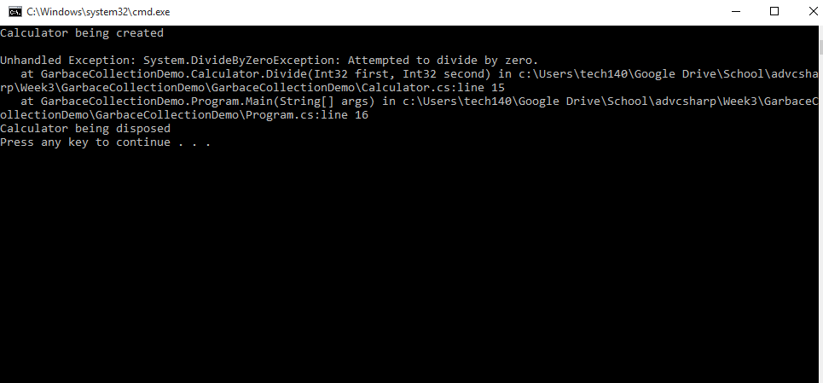

Code:

Programm.cs

using System;

using System.Collections.Generic;

using System.Linq;

using System.Text;

using System.Threading.Tasks;

namespace GarbaceCollectionDemo

{

class Program

{

static void Main(string[] args)

{

using (Calculator calculator = new Calculator())

{

Console.WriteLine("{0} / {1} = {2}", 120, 0, calculator.Divide(120, 0));

}

Console.WriteLine("Program finishing");

}

}

}

Calculator.cs

using System;

using System.Collections.Generic;

using System.Linq;

using System.Text;

using System.Threading.Tasks;

namespace GarbaceCollectionDemo

{

class Calculator : IDisposable

{

private bool disposed = false;

public int Divide(int first, int second)

{

return first / second;

}

public Calculator()

{

Console.WriteLine("Calculator being created");

}

~Calculator()

{

Console.WriteLine("Calculator being finalized");

this.Dispose();

}

public void Dispose()

{

if (!disposed)

{

Console.WriteLine("Calculator being disposed");

}

this.disposed = true;

GC.SuppressFinalize(this);

}

}

}